Getting started with Spring Framework – Approach

JVM

Spring

Address

Age

name

Design Game Runner to run games (Mario, Super Contra Pacman etc) in an iterative approach

1. Iteration 1: Tightly Coupled Java code

. Game Runner

. Game Classes : Mario, SuperContra, Pacman etc

1. Iteration 2: Losse coupling – Interface

. Game Runner class

. Gaming Console interface

\*Game classes : Mario, SuperContra, Pacman etc

Config

POJOs

Q . What is Spring container

Spring container: Manages Spring beans & their lifecycle

IOC Container

=>1. Bean Factory – Basic Spring Container

=>2. Application Context – Advanced Spring Container with

Enterprise-specific features

Ready

System

. Easy to use in web application

. Easy Internationalization

. Easy integration with spring AOP

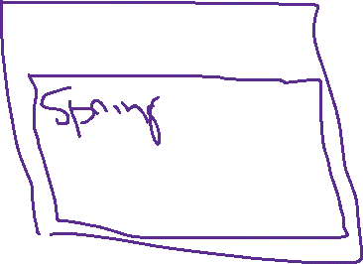

Exploring Java Bean vs POJO vs Spring Bean

Java Bean: Classes adhering to 3 constraints

1. Have public default (no argument) constructors
2. Allow access to their properties using getter and setter methods
3. Implement java.io.Serializable

POJO: Plain Old Java Object

1. No constraints
2. Any Java Object is a POJO

Spring Interview Questions

1. Spring container vs Spring Context vs IOC Container vs ApplicationContext
2. Java Bean vs Spring Bean
3. How can I list all beans managed by Spring Framework
4. What If multiple matching beans are available
5. Spring is managing objects and peforming-auto-wiring
6. BUT aren’t we writing the code to create objects
7. How do we get Spring to create objects for us